published in: OnTrack v. 11/1, 19-22 (2001)

The additional parameters
- a short introduction to the data handling with TRACKKEY 4.1

István Dunkl 1,2
istvan.dunkl@uni-tuebingen.de

1): Institut für Geologie und Paläntologie, Universität Tübingen, Sigwartstrasse 10, D-72076 Tübingen, Germany,
2): Laboratory for Geochemical Research, Budaörsi út 45, H-1112 Budapest, Hungary

During the routine microscopic observation we usually register only three kind of data in the individual crystals: spontaneous and induced counts and the measured area. In case of "simple" samples it is sufficient, but in case of provenance studies or when an igneous rock contains multicompositional apatite grains, the available additional information may carry essential meaning. For example the coupling of the chlorine content or the Dpar to the grain ages, but also simply the microscopic observations: shape, color, zoning etc. In these pages I would like to show examples of such samples containing different groups of crystals and also I aim to give advices to the usage of TRACKKEY version 4.1 for grouping. This program serves a system for the FT data handling - for external detector counting geometry. The main features of this program is already under publication (Dunkl, in press), but the available space in the Computers & Geosciences does not allow to present the system in details and since the submission (1999) I have added several new modules.

System

Thanks to the numerous answers received to my questionnaire asked about the used computer settings I could decide several things. The most important: the main window is bigger, but TRACKKEY 4.x runs only on screen resolution of at least 1024x768 pixels. It is compiled under 32 bits, thus, it does not run under Windows 3.x; it can open and save long file names (but, it is necessary to mention, the usage of extremely long names is discouraged).

Data Input

There are 9 fields available to attach additional information to the dated crystals (Fig. 1). The chlorine, fluorine, Dpar and length fields are strictly numeric. The shape, color and zoning records can carry only one character. There is a further limitation: the content of the shape record is coded to E, S, A and R characters to denote euhedral, subhedral, ahedral and rounded crystals, respectively. The aim of this restriction is to simplify the data selection, grouping, especially in case of amalgamation of several files. The "Goodness" and "Comment" fields can carry both numeric and text data. This nine new fields (beyond the limitation of the "Shape") can be used freely to register any kind of measured parameters.
There is an additional new option: the selection-deselection switch of the individual crystal data is also in this window (Fig. 1).

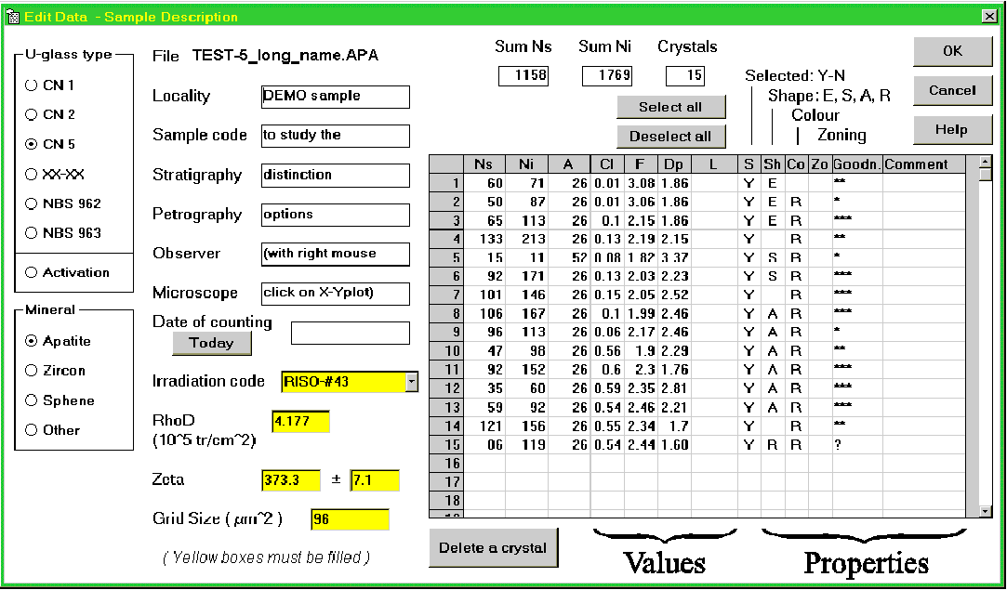

Figure 1: The extended "Edit Data" window. There are 9 additional fields to store chemical composition and characteristic microscopic features beside the registration of Ns, Ni and Area.

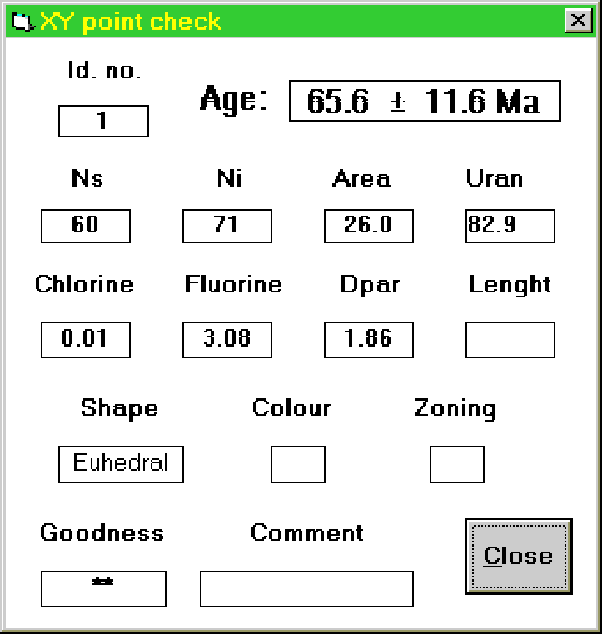

Figure 2: The "X-Y point check" window displays all registered data of a crystal.

Distinction

Records of the grains can be checked individually (Fig. 2), they can be displayed by a left mouse click on the data points on the X-Y plot of the "Main Window". In this way a rapid check may throws light on the reason why some data points occupy outlying position (low counts, extreme composition/Dpar or comments made during microscopic observation).

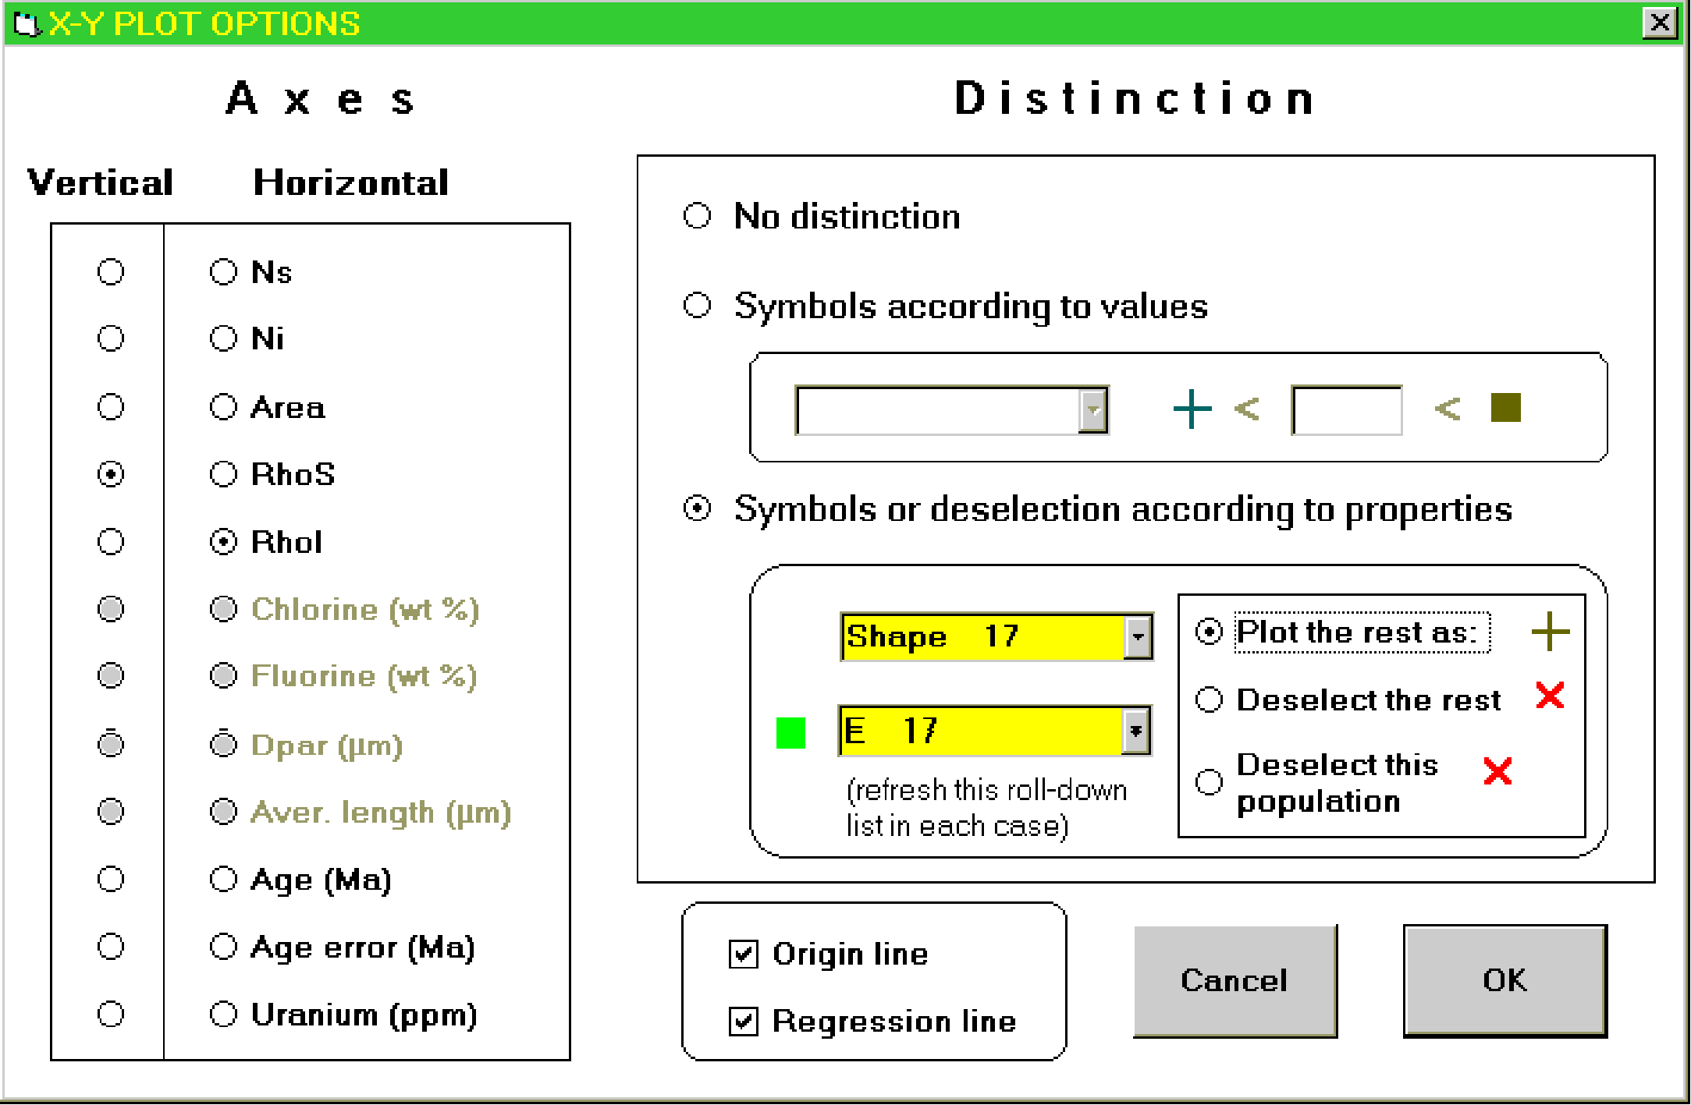

Figure 3: The "X-Y plot options" window. The disabled (grayed out) fields at the left indicate that such values are not present in this file. The distinction and deselection is also controlled from here; in case of deselection not only the plots will be redrawn, but the statistical values will be recalculated, too.

The distinction of the populations can be performed by the "X-Y Plot Option" window: right mouse click on the X-Y plot the "Main Window" (Fig. 3). At the left the user can choose the horizontal and vertical axes of the plot, at the right side there are the distinction possibilities. The "Symbols according to values" option simply splits the population at a given value. The numerical parameters can be used for this purpose. Sometimes the sharing according to the uranium content results in interesting grouping. Split the measured population according to the counted area may reflect errors of track counting and the track registration geometry in 'hard rocks' and may have a meaning on the provenace in case of detrital sediments. The "Symbols and deselection according to properties" option allows to show the grouping according to the aforementioned text records. The upper roll-down list shows in which property do we have at all data and how many (Fig. 4A). The lower roll-down list presents the categories, both the restricted one about the shape and the user-defined text remarks (Fig. 4B and 4C, respectively).

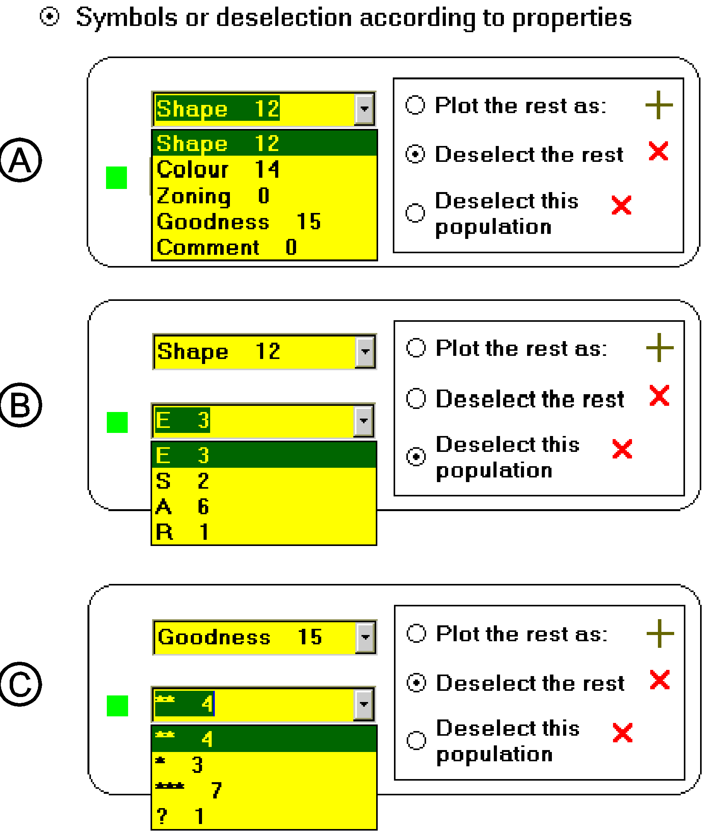

Figure 4: A part of the "X-Y plot options" window. The selection for a distinctive plotting or rejection can be performed according to text data. (A): Number of unique values grouped by properties; (B) and (C): the lower roll-down list shows what kind of categories are registered and how many crystals fall into these categories (E, S, A and R characters representing euhedral, subhedral, ahedral and rounded grains, respectively).

Example I
Figure 3 shows how the distinction is made on a sandstone sample which contains 17 euhedral zircon grains. These are plotted as squares on the "Main Window" and the distinction is also indicated in its lower left corner (Fig. 5). The radial plot and the X-Y plot present a remarkable separation of the euhedral and the rounded zircon populations. It is also clear, that beyond the ca. 50 Ma old euhedral group there is a single euhedral crystal with a rather old FT age. Then what should we do to yield a characteristic FT age for the younger euhedral population?
1) Right mouse click on the X-Y plot and "Deselect the rest" option will leave only the euhedral grains.
2) "X-Y point check" (left click on the old euhedral grain) shows that this outlier, the old one, is the 45th grain.
3) Left mouse click on the statistical data shows the data table and by double click on the "Selected" record of the 45th grain will deselect this one.
After this process only the young euhedral population remains selected and shows the following results: 16 grains give 53±3 Ma central age with the chi-square test P=80%. Thus, we can suppose, that this population derived from a single, distinct, probably volcanic source.

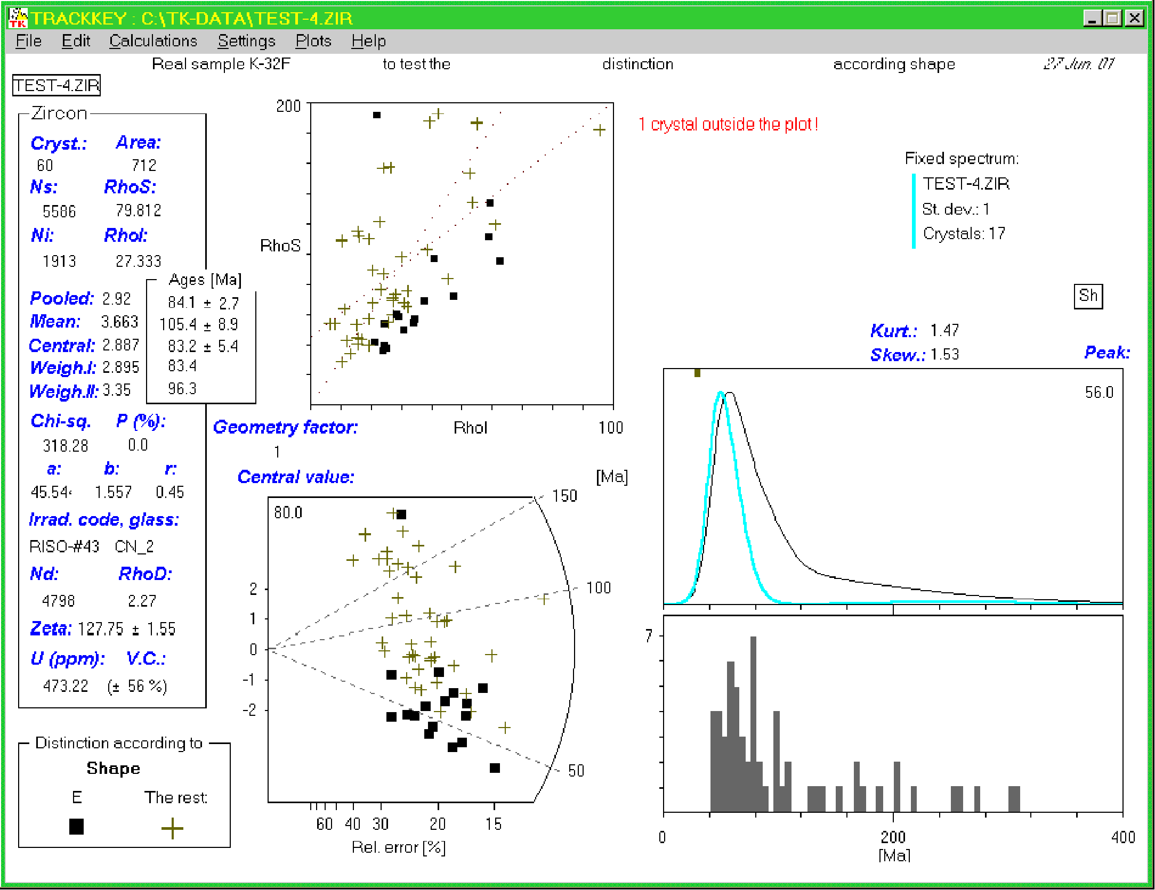

Figure 5: The euhedral grains are shown as squares in the "Main window". The criterion used for the separation is in the bottom left corner of the window.

Example II
Using a very special, but similarly natural sample I would like to show the scope of the grouping according to numeric values such as chlorine, fluorine and uranium content. This is a dike rock of Triassic age which contains numerous endogeneous, igneous inclusions. The apatites of the matrix and the inclusions have distinct shape (big, rounded in the inclusions and euhedral, columnar in the matrix). Further, the microprobe analyses proved that also the Cl and F contents are basically different in this two populations. Figure 6A indicates, that the Cl rich and Cl poor grain populations give similar ages (192±17 and 198±18 Ma central ages, respectively). It means, that although the samples underwent some rejuvenation, the expected drift is not observable, just in contrary, the chlorine poor population has a bit older age. Figures 6B and 6C carry a kind of petrogenetic meaning. Not only the Cl content makes sharp separation, but also the uranium content (Fig. 6B). Nearly all Cl rich crystals have low U content. The squares represent euhedral grains, the "X" symbols rounded, ahedral ones. It is obvious from the plot, that not all the Cl rich grains have euhedral shape. It is also possible to make a separation by the F content (in this case splitting at F=2 wt.%). Noticeable from the plots, that there is a grain which is (I) rounded, (II) Cl rich, (III) F poor and (IV) U rich. This grain does not belong to the two well constrained groups and represents a petrogenetic link between the two non-miscible magmas.
The distinct populations are also plotted in the DXF export file (menu: File / Export / DXF file), which can be imported as a vector graphic by nearly all drawing programs.

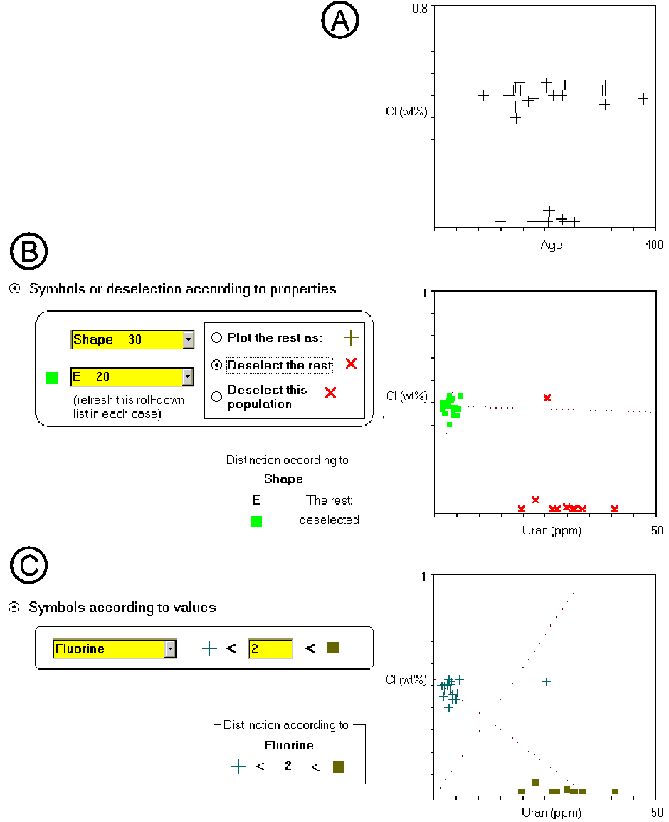

Figure 6: Multiparameter evaluation of a composite sample. This figure is composed of extracted parts of the "X-Y plot options" window (at the left, showing how the selection was made) and the X-Y plots are extracted from the "Main window", to present how the separation looks like.

Additional new features

The "Main Window" indicates what kind of additional information is linked to the crystal data. In the right side of Figure 5 the Sh symbol indicate that this file contains data on shape. The existence of chlorine, fluorine, etc. data are also indicated there.
Several trackers use the external surface of the zircons for spontaneous track counting. They need a geometry factor of 1 instead of the 0.5 value which is used in case of 2π/4π counting geometry (Gleadow, 1981). The geometry factor can be modified at the "Settings" menu and when it is not equal to 0.5 it is indicated on the "Main Window" (see Figure 5, beside the chi-square test) and also all age and zeta calculating windows and prints.

Software availability

The program needs several DLL files which are not parts of the Windows operation system. Thus, each computer needs an installation procedure once. New versions of the EXE file of the program can be run without reinstallation, only the old version of the executable should be replaced by the new one.
The setup kit of the program, a short instruction file for the installation (READ_ME_TK_4.1.TXT) and the synthetic and natural example files which are used above (placed in the TK-DATA directory) will be available on the IAMG anonymous ftp site [http://www.iamg.org/] and from my web site soon [http://www.uni-tuebingen.de/geo/gpi/ag-frisch/mitarbeiter/dunkl/index.html]. It should be practical to register at me by an e-mail at the download, thus, I will be able to inform the users on the updates in the future. The program is freeware, but I kindly ask the users to cite the C. & G. paper.

Acknowledgements

I have received very useful comments and suggestions from the members of the Tübingen FT group, especially from Balázs Székely. Many thanks.

References

Dunkl, I. (in press): TRACKKEY: a Windows program for calculation and graphical presentation of fission track data. Computers & Geosciences, 28(2).
Gleadow, A. J. W. (1981): Fission-track dating methods: What are the real alternatives? Nucl. Tracks, 5, 3-14.

